**DAILY ONLINE ACTIVITIES SUMMARY**

|  |  |  |  |  |  |  |  |  |
| --- | --- | --- | --- | --- | --- | --- | --- | --- |
| **Date:** | **11/06/2020** | | | | | **Name:** | **Manish B Shriyan** | |
| **Sem & Sec** | **8th sem B sec** | | | | | **USN:** | **4AL16CS131** | |
| **Online Test Summary** | | | | | | | | |
| **Subject** | | **SMS** | | | | | | |
| **Max. Marks** | | **60** | | **Score** | | | **60** | |
| **Certification Course Summary** | | | | | | | | |
| **Course** | **Be A White Hat Hacker and Pen Tester** | | | | | | | |
| **Certificate Provider** | | | **Eduonix** | | **Duration** | | | **4.5 Hours** |
| **Coding Challenges** | | | | | | | | |
| **Problem Statement:**  **Python3 program to print the Minimum String**  **length** | | | | | | | | |
| **Status: Solved** | | | | | | | | |
| **Uploaded the report in Github** | | | | | **Uploaded** | | | |
| **If yes Repository name** | | | | | **ManishShriyan** | | | |
| **Uploaded the report in slack** | | | | | **Yes** | | | |

Online Test Details:

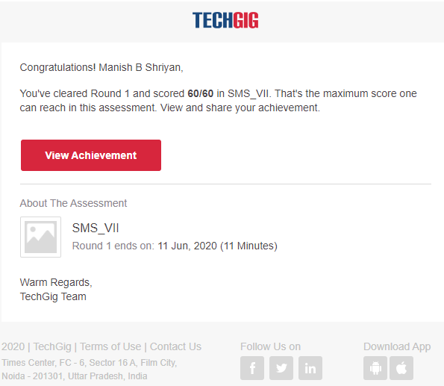

Certification Course Details:

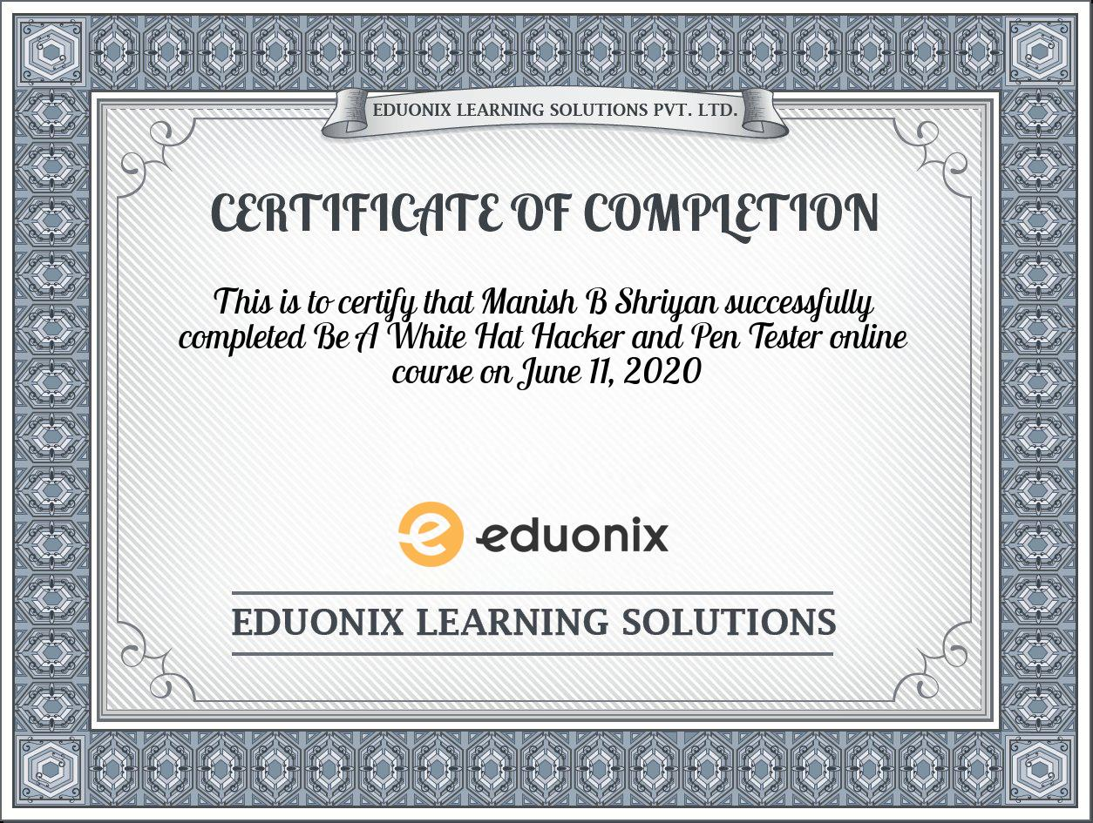

Coding Challenges Details:

|  |
| --- |
|  |
|  |  |
|  |  |
|  |  |
|  |  |
|  |  |
|  |  |
|  |  |
|  |  |
|  |  |
|  |  |

test_list = ['python', 'java', 'c++']

print("The original list : " + str(test_list))

res = min(len(ele) for ele in test_list)

print("Length of minimum string is : " + str(res))